Ean Masoner Module 2.3 Assignment

ERD Screenshot

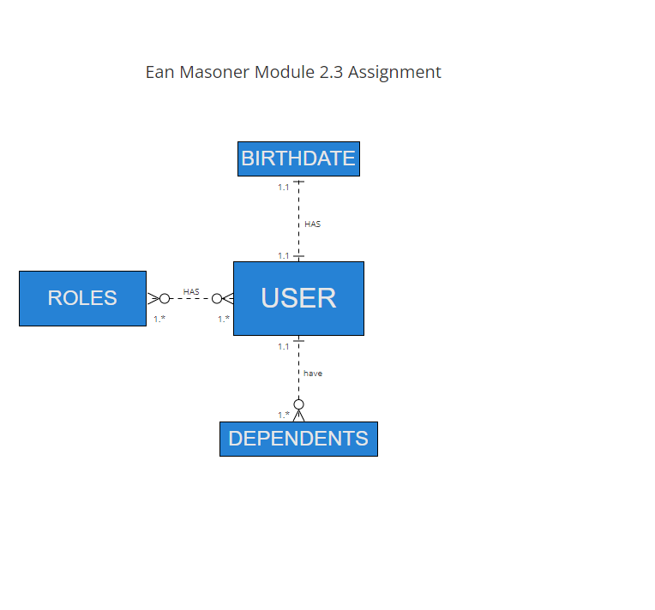

No SQL structure Screenshot

